**Team 52 - PartyFreaks – PartyGuard Web Application**

**Client:** Jacob Stansbury ([S516098@mail.nwmissouri.edu](mailto:S516098@mail.nwmissouri.edu))

**Roles and Responsibilities:**

1. **Primary Contact:**Prem Abishai Parise
2. **Client management:**Nihitha Reddy Bhimireddy
3. **Requirements management:**Lokesh Reddy Pothapu
4. **Data management:**Srichaitanya Peddinti
5. **Issues management:**Sindhuja Pannala
6. **Quality and testing management:**Spandana Velaga
7. **Communications and documentation management:**Gopinadh Cherupally

**Artifacts:**

|  |  |  |  |
| --- | --- | --- | --- |
| **Name** | **Artifact** | **Evaluation** | **%Complete** |
| Prem Abishai Parise | Add customer | Implemented API functionality | 100% |
| Customer Acknowledgement | Implemented API functionality | 100% |
| Dashboard | Implemented API functionality | 100% |
| View customers | Implemented API functionality | 100% |
| Login | Implemented API functionality and navigation | 100% |
| Guard Registration | Implemented API functionality | 100% |
| Nihitha Reddy Bhimireddy | Email functionality on home page | Resolved email issue | 90% |
| Email functionality on Customer acknowledgement page | Resolved email issue | 90% |
| Spandana Velaga | Guard User Profile | Implemented API functionality | 100% |
| Guard user Profile Edit | Implemented API functionality | 100% |
| Change password | Implemented API functionality | 100% |
| Lokesh reddy Pothapu | Basic user profile | Implemented API functionality | 90% |
| Basic user Profile Edit | Implemented API functionality | 90% |
| Change password | Implemented API functionality | 90% |
| Srichaitanya Peddinti | members.html | Completed the functionality in members.html page | 90% |
| events creation page | worked on events creation page | 80% |
| Event confirmation page | Created and implemented functionality | 80% |
| Gopinadh Cherupally | Guard user Testing | Testing Guard user pages and integration testing | 90% |
| Sindhuja Pannala |  |  |  |

**Accomplishments:**

**Prem Abishai Parise:**

Hrs Worked: 20

Implemented API functionality in Add customer page:

Repo link:

<https://github.com/s525080/PartyGuardWeb/blob/master/app/view/MasterUser/AddCustomer.html>

<https://github.com/s525080/PartyGuardWeb/blob/master/app/controller/AddCustomer.js>

Screenshot:

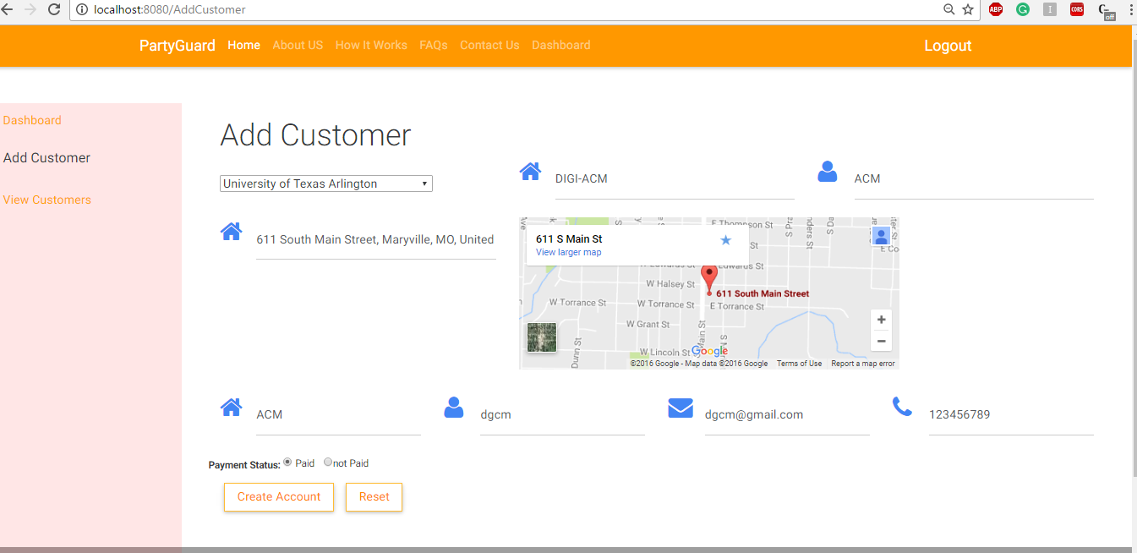

Implemented API functionality in Dashboard

Repo link:

<https://github.com/s525080/PartyGuardWeb/blob/master/app/view/MasterUser/Dashboard.html>

<https://github.com/s525080/PartyGuardWeb/blob/master/app/controller/Dashboard.js>

Screenshot:

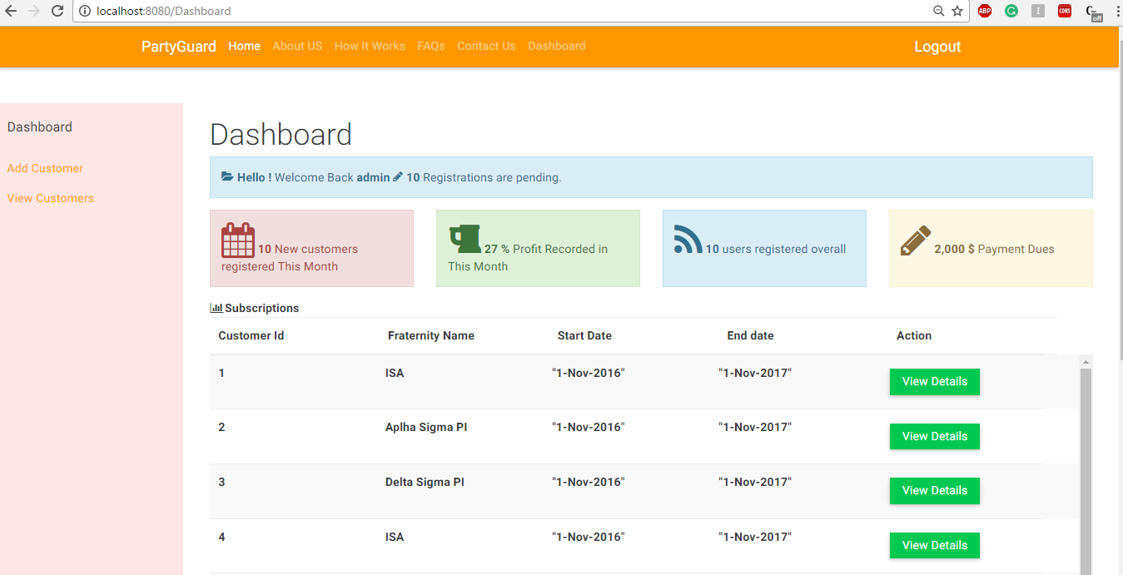

Implemented API functionality in Customer acknowledgement page

Repo link:

<https://github.com/s525080/PartyGuardWeb/blob/master/app/view/MasterUser/AddAck.html>

<https://github.com/s525080/PartyGuardWeb/blob/master/app/controller/Addack.js>

Screenshot:

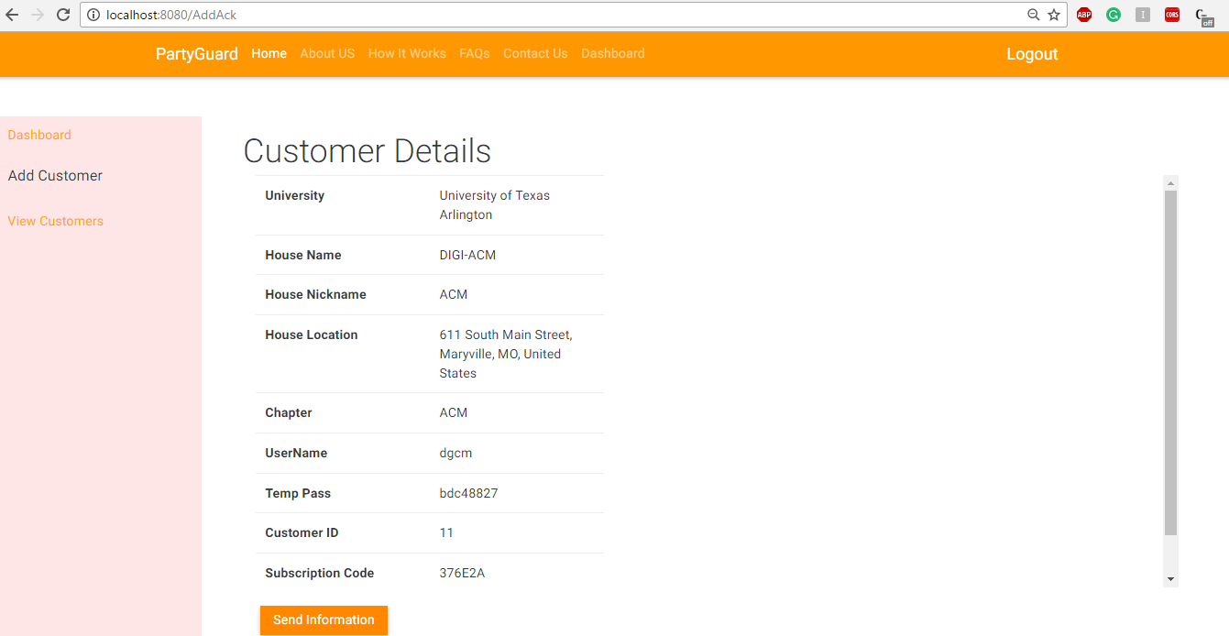

Implemented API functionality in view Customers page

Repo link:

<https://github.com/s525080/PartyGuardWeb/blob/master/app/view/MasterUser/ViewCustomers.html>

<https://github.com/s525080/PartyGuardWeb/blob/master/app/controller/viewcustomer.js>

Screenshot:

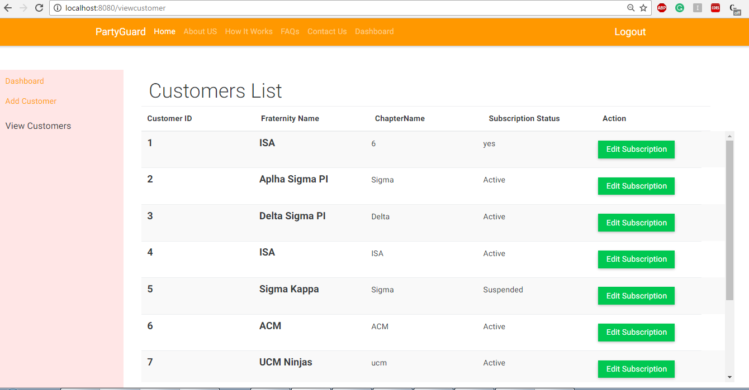

Implemented API functionality in Login page

Repo link:

<https://github.com/s525080/PartyGuardWeb/blob/master/app/view/Navbar/Login.html>

<https://github.com/s525080/PartyGuardWeb/blob/master/app/controller/authentication/Login.js>

<https://github.com/s525080/PartyGuardWeb/blob/master/app/controller/authentication/services.js>

Screenshot:

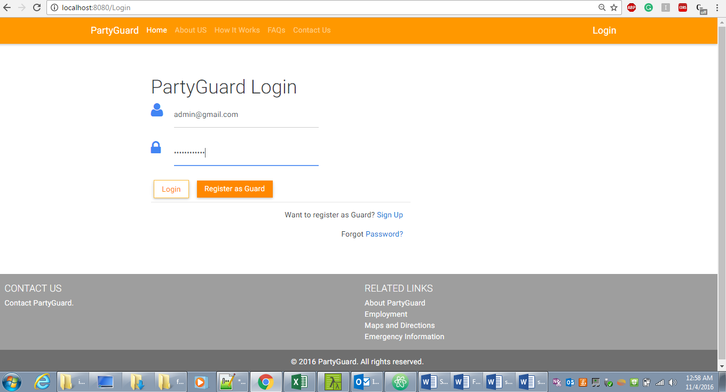

Implemented API functionality in Guard Registration page

Repo link:

<https://github.com/s525080/PartyGuardWeb/blob/master/app/view/GuardUser/GuardRegistration.html>

<https://github.com/s525080/PartyGuardWeb/blob/master/app/controller/Guardregistration.js>

Screenshot:

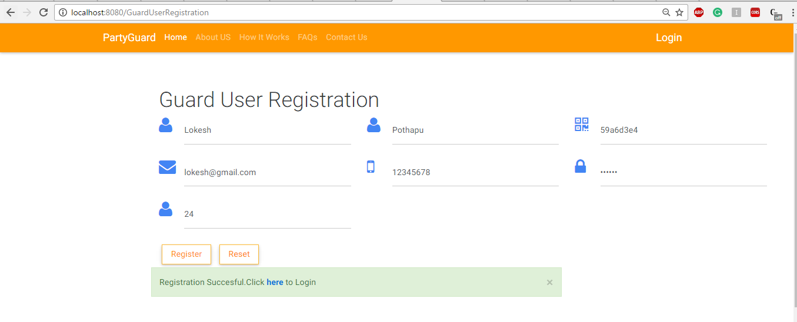

**Nihitha Reddy Bhimireddy:**

Resolved email functionality issue in both homepage and Customer acknowledgement page.

Hrs Worked: 15

Repo links:

<https://github.com/s525080/PartyGuardWeb/blob/master/app/controller/default.js>

<https://github.com/s525080/PartyGuardWeb/blob/master/app/controller/Addack.js>

<https://github.com/s525080/PartyGuardWeb/blob/master/server.js>

Screenshots:

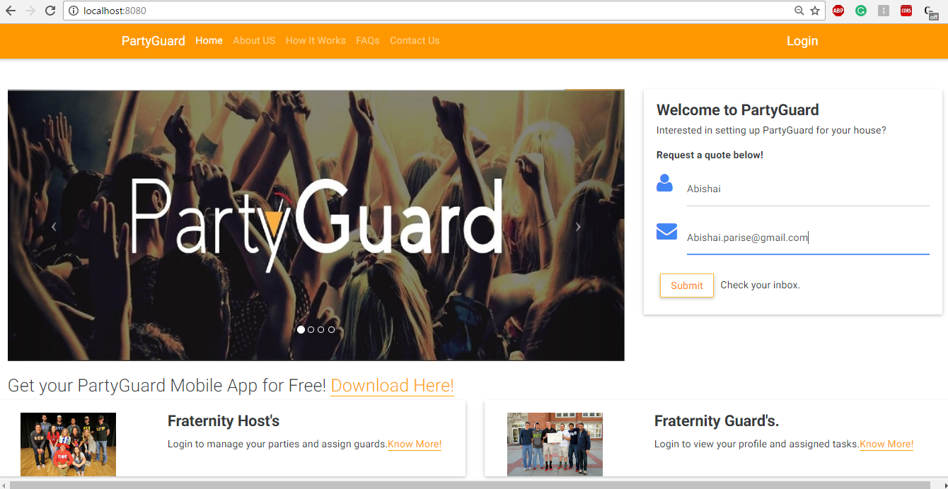

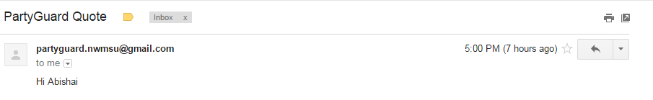

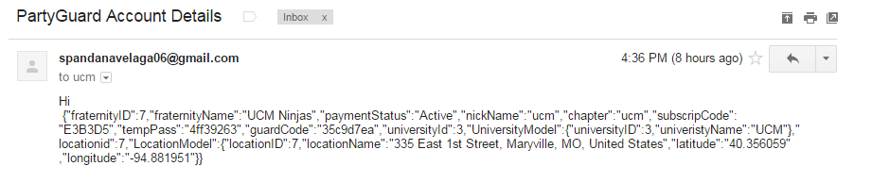

**Spandana Velaga:**

Implemented API functionality in Guard Module.

Hrs Worked: 15

Repo links:

<https://github.com/s525080/PartyGuardWeb/blob/master/app/view/GuardUser/GuardRegistration.html>

<https://github.com/s525080/PartyGuardWeb/blob/master/app/view/GuardUser/GuardUserEdit.html>

<https://github.com/s525080/PartyGuardWeb/blob/master/app/view/GuardUser/guardpassword.html>

<https://github.com/s525080/PartyGuardWeb/blob/master/app/controller/GuardUser.js>

<https://github.com/s525080/PartyGuardWeb/blob/master/app/controller/guardpassword.js>

<https://github.com/s525080/PartyGuardWeb/blob/master/app/controller/guarduseredit.js>

Screenshot:

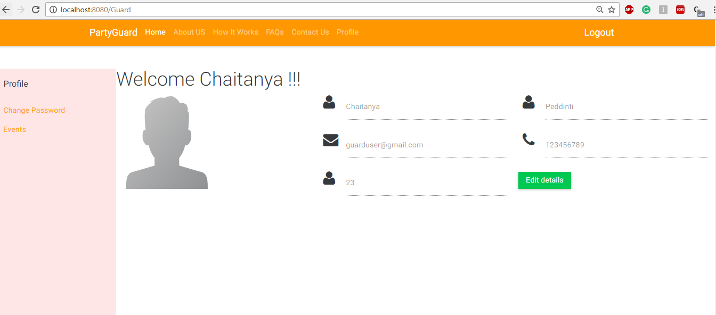

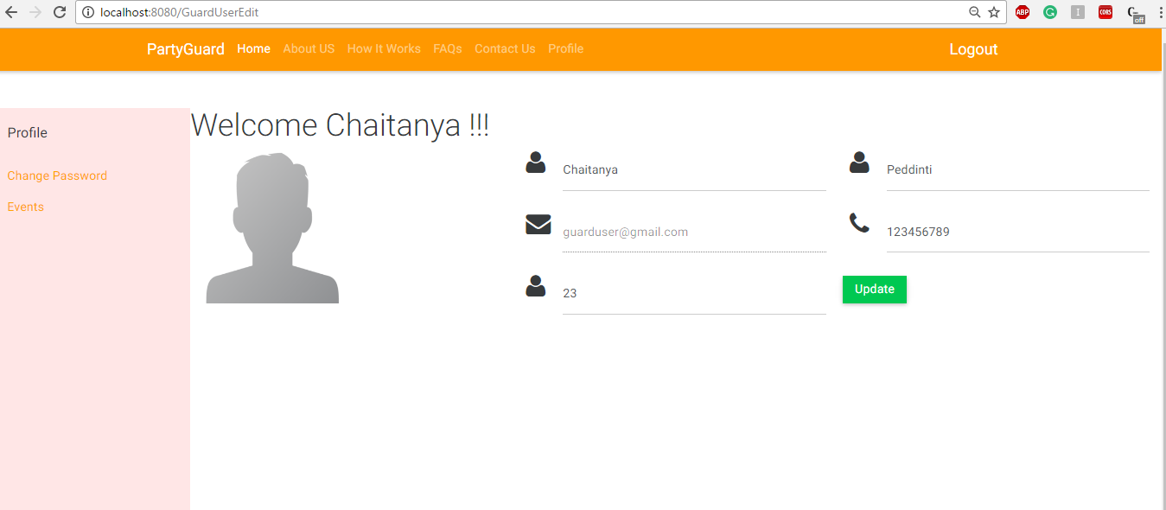

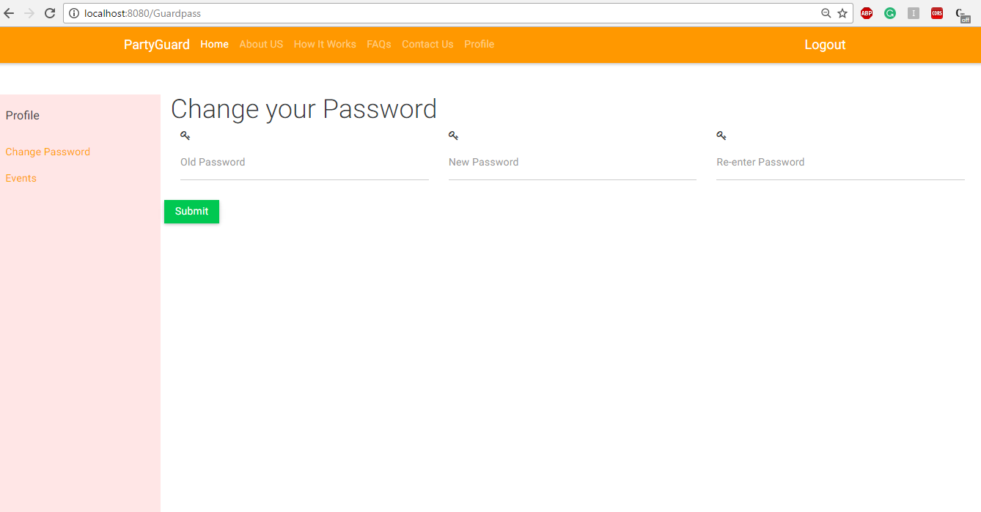

Srichaitanya Peddinti:

Hrs worked: 15

* Completed the functionality in members.html page. Additionally, worked on events creation page too.

<https://github.com/s525080/PartyGuardWeb/blob/master/app/view/HostUser/EditEvents.html>

<https://github.com/s525080/PartyGuardWeb/blob/master/app/view/HostUser/Events.html>

* Created Event confirmation page
* <https://github.com/s525080/PartyGuardWeb/blob/master/app/view/HostUser/EventConfirmation.html>
* Modified all host pages as per instructor comments

<https://github.com/s525080/PartyGuardWeb/blob/master/app/view/HostUser/Members.html>

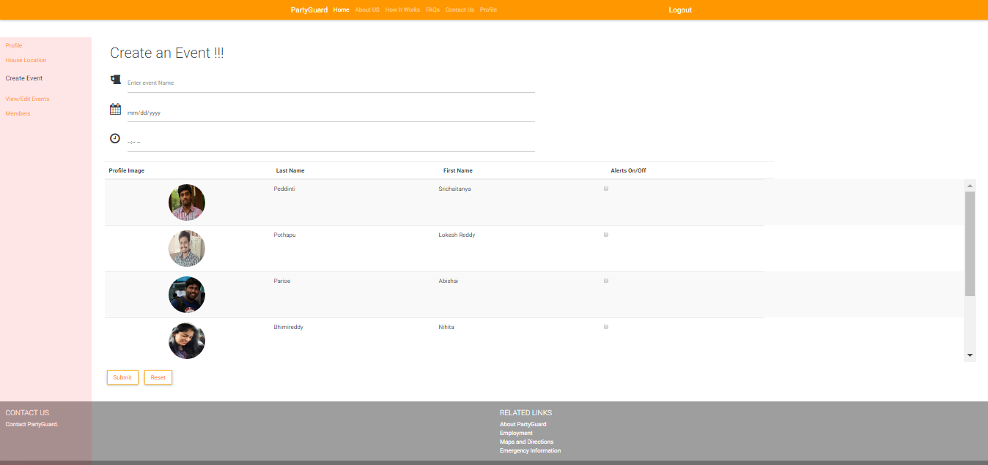

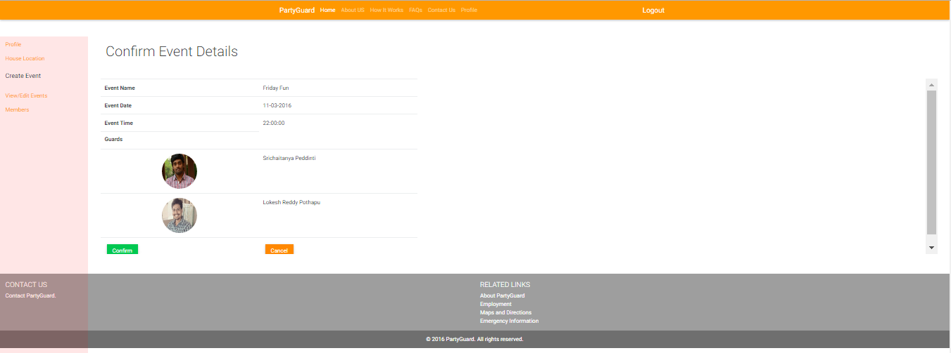

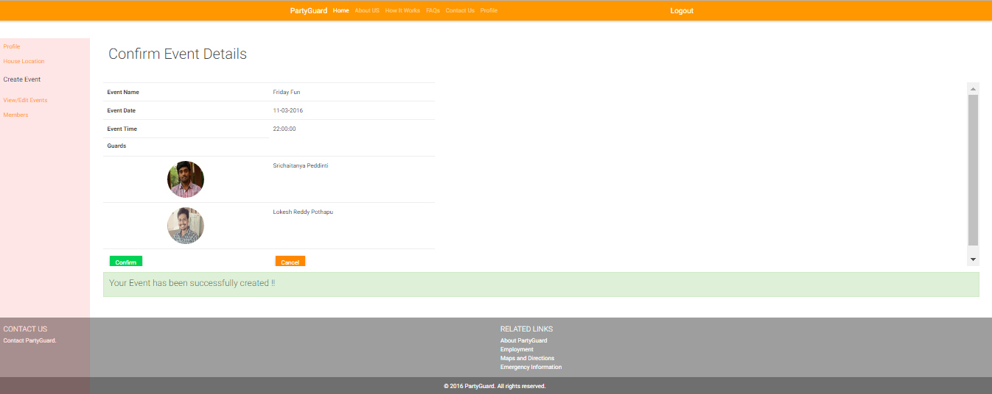

Lokesh Reddy Pothapu:

Added Api functionality for change password functionality

Getting Basic user details from API and added edit functionality.

Hrs worked:15

Repo Links:

<https://github.com/s525080/PartyGuardWeb/blob/aa743c54031591bd8d03a23430fb6b5ed8b3d671/password.html>

<https://github.com/s525080/PartyGuardWeb/blob/d9aef53c0cdabec86691288283f15cac61b7e5f6/BasicProfile.html>

<https://github.com/s525080/PartyGuardWeb/blob/71ab93ba26a35f06c38f700d25bd1a50272d275b/BasicUserEdit.html>

<https://github.com/s525080/PartyGuardWeb/blob/359eb9da54fa00cdb64fbf322a620097a65d1591/BasicUser.js>

<https://github.com/s525080/PartyGuardWeb/blob/ad2d6130999bd0c5388eba89445227266aa5d20b/basicuseredit.js>

<https://github.com/s525080/PartyGuardWeb/blob/3439cbedbec565f01fb0918e3a8b6ee033df6837/BasicPassowrd.js>

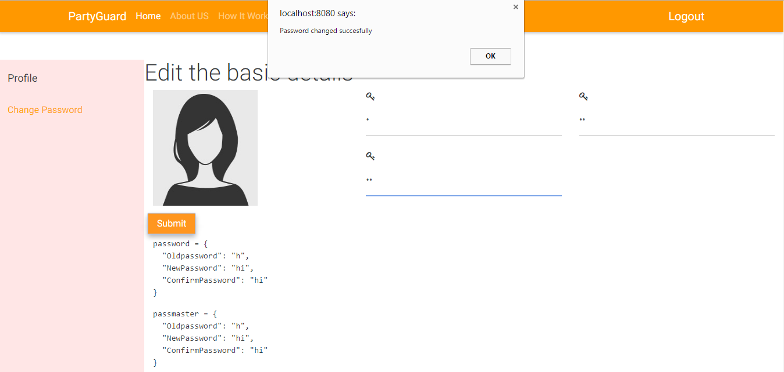

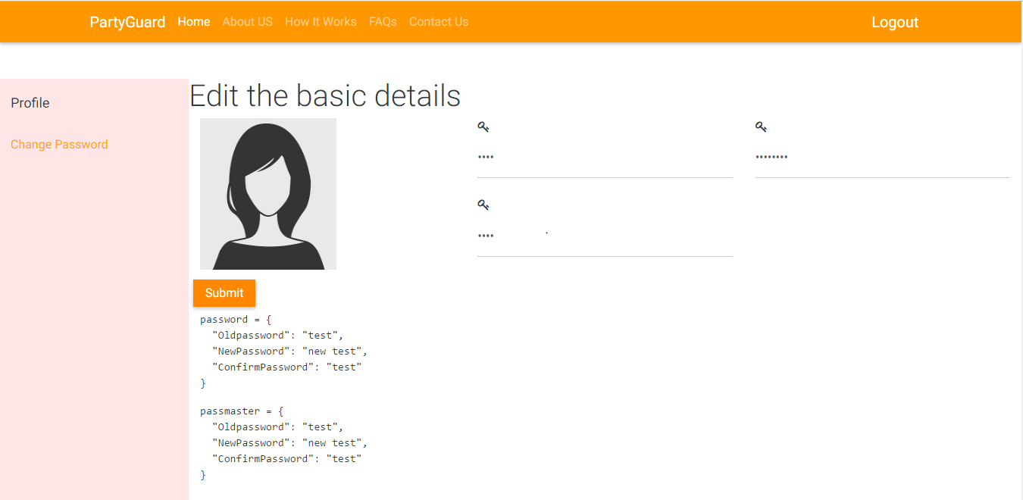

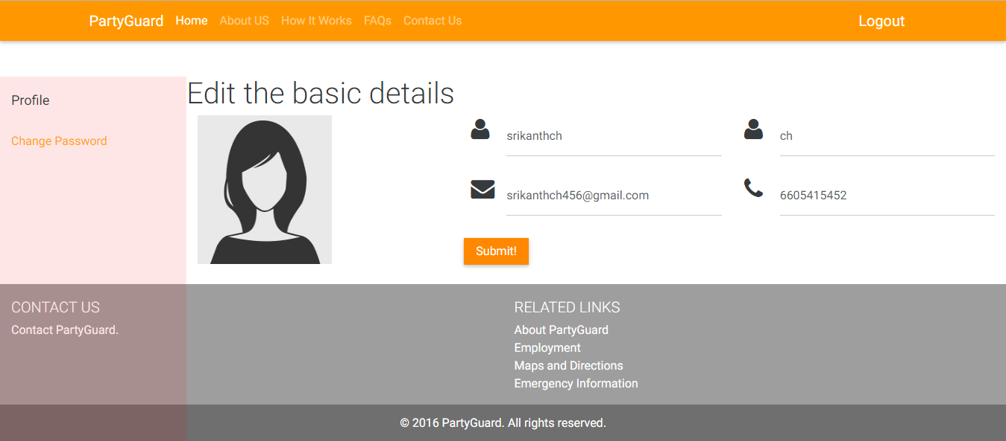

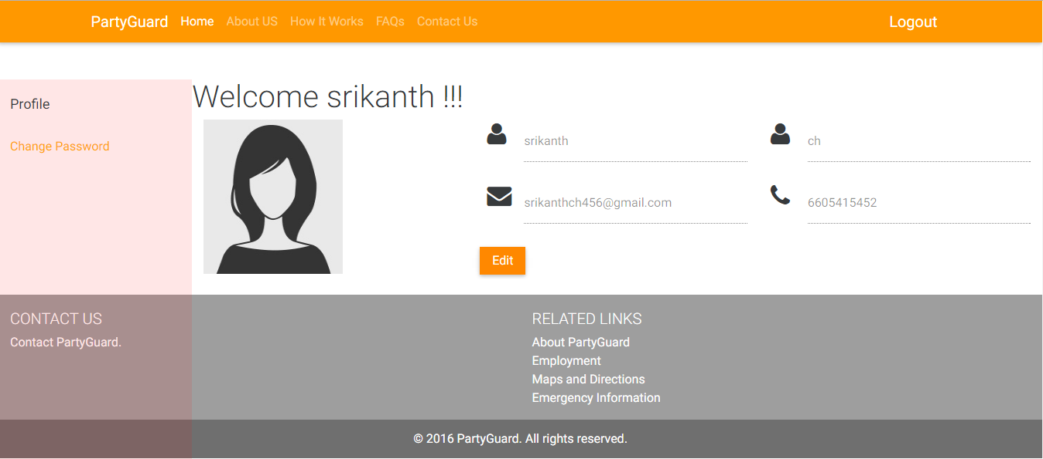

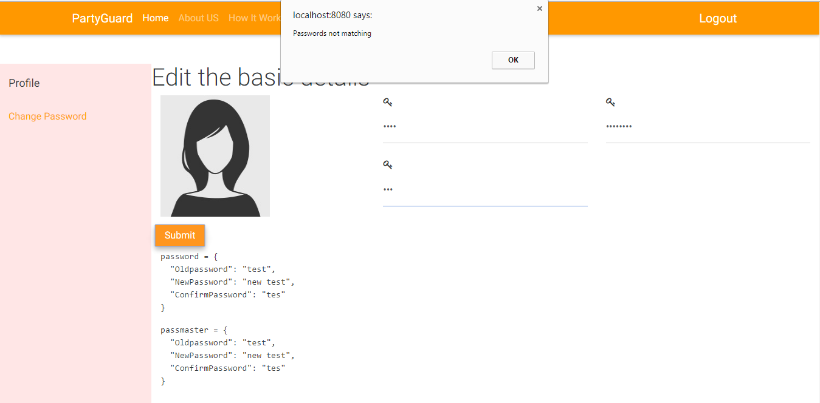

Gopinadh Cherupally:

Testing Guard user pages and integration testing

Hrs worked: 15

Repo Links:

<https://github.com/s525080/PartyGuardWeb/commit/a17af1c2334aff54c9b078137a1a7906a7b45f92>

<https://github.com/s525080/PartyGuardWeb/commit/e857ce35e45cd59e61c6d65631d96bcc739aa27c>

<https://github.com/s525080/PartyGuardWeb/blob/54c7eb5c6eb00fecc532088a17bb80c93f365ee8/integrationesting.xlsx>

<https://github.com/s525080/PartyGuardWeb/blob/d616386a16f30f4300ddaf325ed136a4d1e20588/guardprofile.xlsx>

<https://github.com/s525080/PartyGuardWeb/blob/a97fa45b9757717370c7d11e5ca6b32ed2015741/guardlogin.xlsx>

<https://github.com/s525080/PartyGuardWeb/blob/36945d1a7df20436e1baec4d8a0b12a1ba8af2d1/guardchangepassword.xlsx>

Planned Tasks:

|  |  |  |  |
| --- | --- | --- | --- |
| Name | Task | Hours | Deliverable |
| Prem Abishai Parise | Cross team Testing & remaining API functionality implementation | 15 | Repo links and screenshots |
| Nihitha Reddy Bhimireddy | Testing API functionality in Admin module and Login &  Integration testing | 15 | Test results |
| Spandana Velaga | Testing API functionality in  Host module Integration testing | 15 | Test results |
| Gopinadh Cherupally | Testing API functionality in  Guard module and Basic user Module Integration testing | 15 | Test results |
| Srichaitanya Peddinti | API functionality in Host user pages like Events ,view events | 15 | Repo links and screenshots |
| Lokesh Reddy Pothapu | Implement API functionality in forgot password,Contact us pages | 15 | Repo links and screenshots |
| Sindhuja Pannala | Documentaion | 10 | Project artifats |